**AN LAC SEAFOOD CO., LTD. (HK216)**

Lot A14, 4A Str., Hai Son Industrial Zone, Duc Hoa District, Long An Province, Vietnam.

Tel: 84-072-3850606 Fax : 84-072-3850608

**SALES CONTRACT**

No.: 02/AL-BIO/2015

Date: May 01, 2015

***The Seller:* AN LAC SEAFOOD CO., LTD.**

Add.: Lot A14, 4A Str.,HaiSon Industrial Zone, DucHoa District, Long An Province,Viet Nam.

Tel : 84-072-3850606 Fax : 84-072-3850608

Represented by: Mr. ***NGUYEN THIEN DUY*** – ***Director***

***The******Buyer***: **BIOVITAL COMPANY**

Address: UKRAINE, 49051 DNEPROPETROVSK, UL. B.KHMELNITSKOGO 4  
Tel.: 0038 0577322007    Fax: 0038 0675706385

Represented by: NAYALYA V. KRYVENKO – Director

Follow confirmation Pro. No.: 01 both parties to sign for sale purchase contract with terms and conditions:

***ARTICLE 1*: Commodities:**

|  |  |  |  |  |  |
| --- | --- | --- | --- | --- | --- |
| **No.** | **DESCRIPTION OF GOODS** | **QUANTITY** | | **CIF ODESSA PORT UKRAINA** | |
| CARTONS | KGS | UNIT PRICE (USD/KG) | AMOUNT  (USD) |
| 01. | DRIED SALTED ROUND SCAD | 1,534 | 23,010.00 | 5.20 | 119,652.00 |
| **TOTAL** | | **1,534** | **23,010.00** |  | **119,652.00** |

***ARTICLE 2:*** ***Packing:*** export standard. (15 kgs /carton)

ARTICLE 3: Shipment – delivery

Date of shipment : Before June 30, 2015.

Loading port : HOCHIMINH PORT, VIETNAM.

Discharging port : ODESSA PORT, UKRAINE

Partial shipment : Allowed

Transshipment : Allowed

**Article 4: *Payment:***

By TTR into account of The Seller’s No: 1402 148 5100 9479 at Vietnam Eximbank District 04, Branch in Ho Chi Minh

**Article 5:** ***General Provision:***

Both parties under take themselves to perform fully responsibilities and obligations of this contract any disputes will be setted by Vietnam International Arbitration Center in HoChiMinh City, under International Trade Law whose decision will be final and binding the both parties. The contract signing by fax was accepted and is made in 2 copies that have same legal value, 2 of which for each party and valid to December 31, 2015.

## THE BUYER THE SELLER

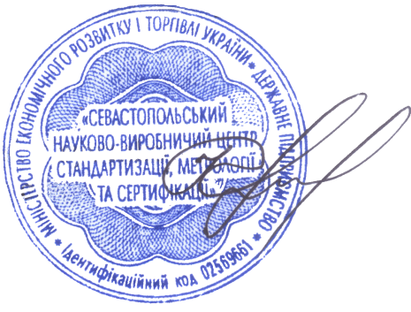

Nayalya V. Kryvenko